# Exercise 1 - The JMP Table

We will open a JMP table and make sure that we understand the different parts of the table window.

1. Start JMP
2. Examine various windows opened automatically, then close them
3. Open a table using Help/Sample Data/Teaching Resources/Examples for Teaching/Auto Raw Data  
   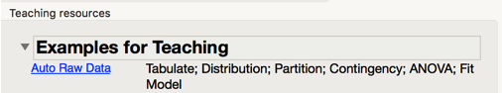
4. Examine the interface
   1. Table in rows, columns
   2. List of saved scripts (top left)
   3. Column list (mid left)
   4. Rows (bottom left)
5. Red triangles can be clicked on to give extra functionality, so try clicking on these and making some selections  
   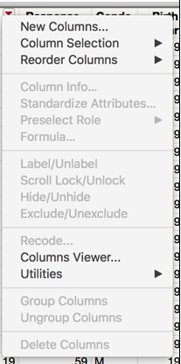
   1. Some red triangles will give you different options depending on what selections you have made in the table.
      1. Try clicking on a column name in the centre left list of columns, then click on red arrow there.
   2. Click on the red arrow next to Rows, and choose Data Filter  
      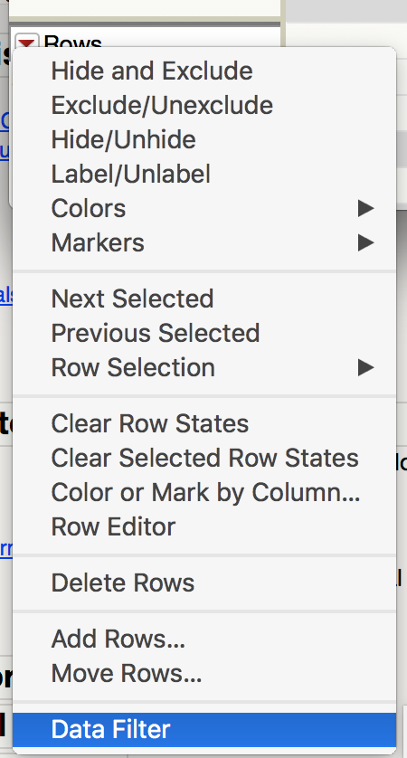  
      and now make a Data Filter to see what that does…
6. Click on the gray triangles, which open and close panels
7. Right click almost anywhere for specific functionality to where you click
   1. Try right clicks on
      1. column headers, both on the name of a column and in blank column
      2. row headers, both on row number and blank row at end of table
      3. cells
      4. items in
         1. top left box
         2. middle left box
         3. bottom left box
8. Load some SAS datasets
   1. File/Open
   2. Navigate to the data directory for this workshop
   3. Open the tables there  
      